HW #3c

Instructions:

1. The deadline will be the end of this week, i.e., 11:59pm, Sept. 25, 2016.
2. Pls don’t submit until you complete all HWs, that is HW #3a, 3b, 3c.
3. pls combine all HWs into one file, then submit it to D2L.

**[Problem 1]** Design a 3-bit binary up counter by D Flip-Flops.

**[Problem 2]** Draw the output waveform of D flip-flop triggered with positive edge.

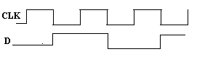

**[Problem 3]** Draw the output waveform of D flip-flop triggered with negative edge.

